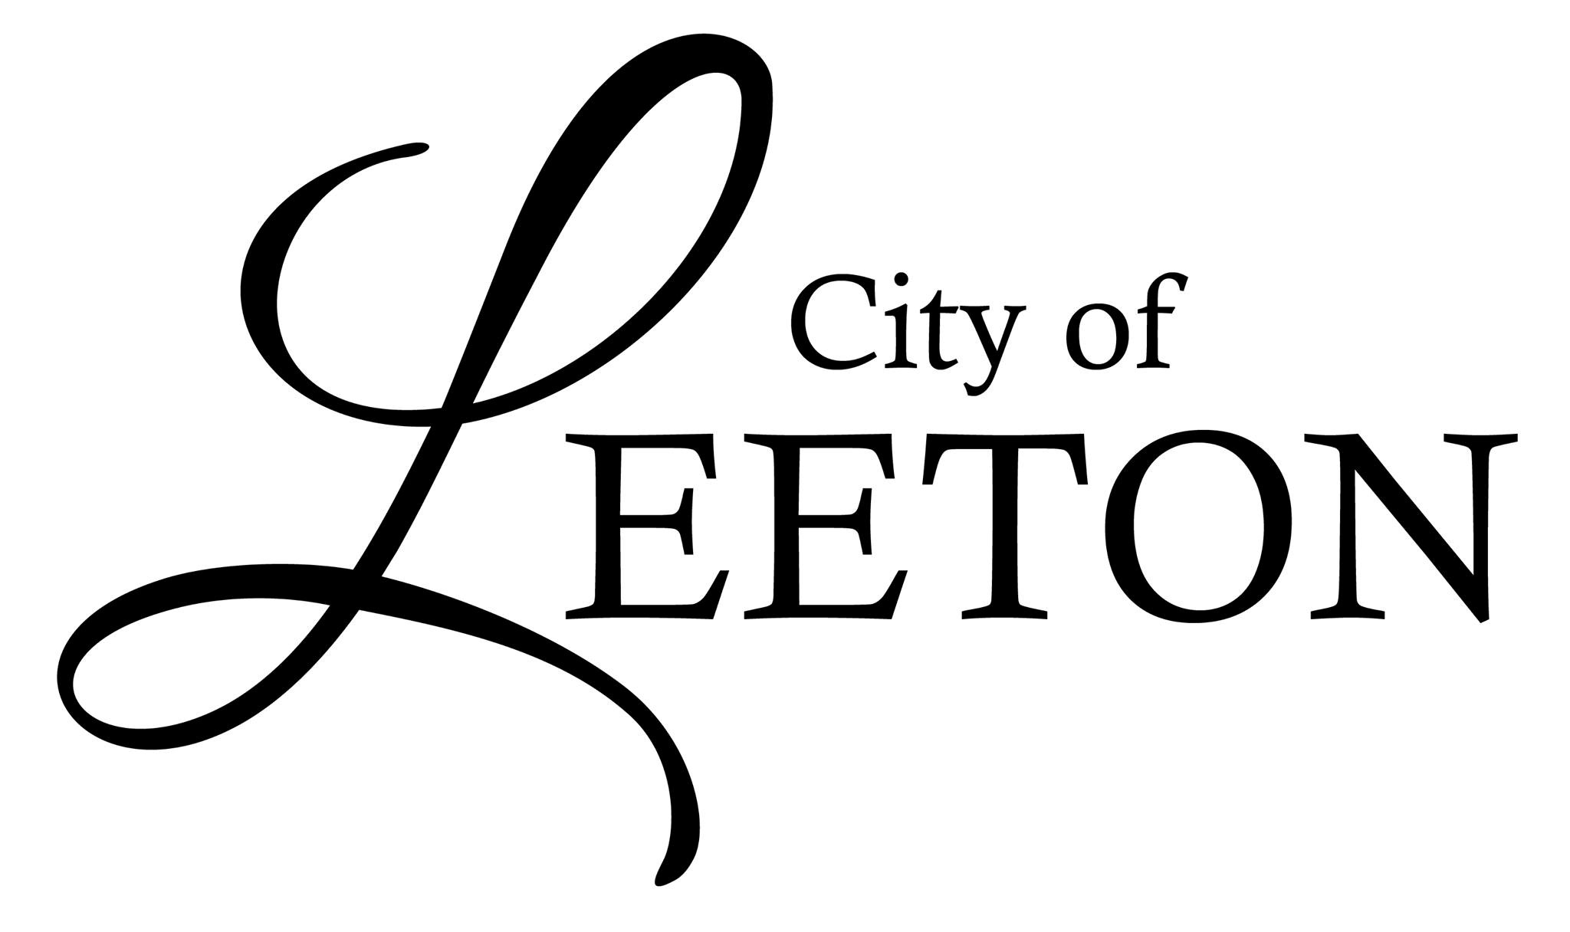
Janet Muse, City Collector
cityofleeton@gmail.com
108 W Summerfield Ave – PO Box 87 – Leeton MO 64761
660-653-4622 Fax 660-653-4575
Business Hours
Monday -Thursday 9:00-2:00
Hen/Pullet Application
City Ordinance 428 requires that all persons within the City Limits who own hens/pullets must obtain a hen/pullet permit. Failure to obtain a hen/pullet permit could result in a citation.
Permit fee is $10.00. Include a sketch of your property and the location of your house and the coop/run.
Date of Application:

Name of Hen/Pullet Owner:

Street Address of Hen/Pullet Owner:

City – State – Zip Code:

Mailing Address (if different from above):

Phone Number of Hen/Pullet Owner:

Dimensions of Applicant’s Premises:

Housing/Run Type with Dimensions:

Housing/Run Location on Property:

Housing/Run Distance from Nearest Dwelling (not owned by applicant):

License Fees:

The undersigned certifies the above information to be true and correct according to the undersigned’s best knowledge and belief.

___________________________________________
Applicant’s Signature & Date
City Information

City Permit # and Date Issued:
Amount Paid:
Date Paid:

REGULATIONS FOR HENS/PULLETS

- Hens/pullets must be kept in an enclosed or fenced area during daylight hours and secured within a henhouse or chicken tractor during non-daylight hours.
- Each hen/pullet shall be provided with a minimum of four (4) square feet per bird of exterior enclosed area and four (4) square feet of interior area, aggregating to eight (8) square feet for each hen/pullet.
- Enclosures, interior or exterior, must be kept in a neat, clean, dry, odor-free and sanitary condition.
- Henhouses, enclosures and pens must provided adequate ventilation, sun and shade and must be impermeable to rodents, wild birds and predators, including cats and dogs.
- Henhouses and enclosures shall provide safe and healthy living conditions for the hens/pullets, while minimizing the adverse impacts to other residents of the City.
- Henhouses, enclosures and chicken runs may be located only to the rear of the dwelling or main structure.
- Henhouses, enclosures and chicken runs may be located no closer than ten (10) feet to the applicant’s property line and at least and fifty (50) feet from the nearest part of any residence or dwelling upon an adjacent, non-owned property by the applicant.

MAXIMUM NUMBER OF HENS/PULLLETS

- The maximum number of hens/pullets allowed shall not exceed twelve (12) at any one time.
- Only female chickens (pullets or hens) are allowed.

